**30. Query to display the number of employees performing the same Job type functions.**

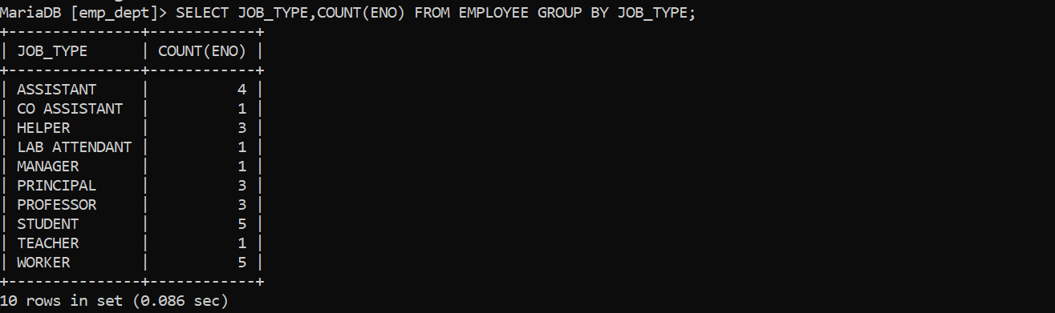

**31. Query to display the total number of supervisors without listing their names.**

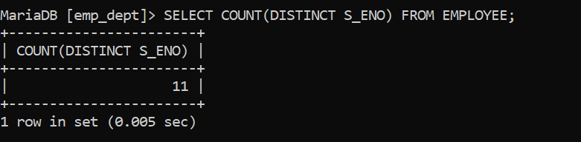

**32. Query to display the Department Name, Location Name, No. of Employees and the average salary for all employees in that department.**

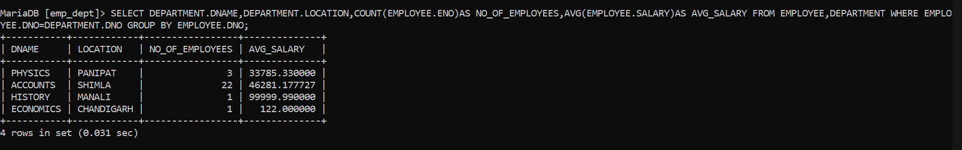

**33. Query to display Name and Hire Date for all employees in the same dept. as Blake.**

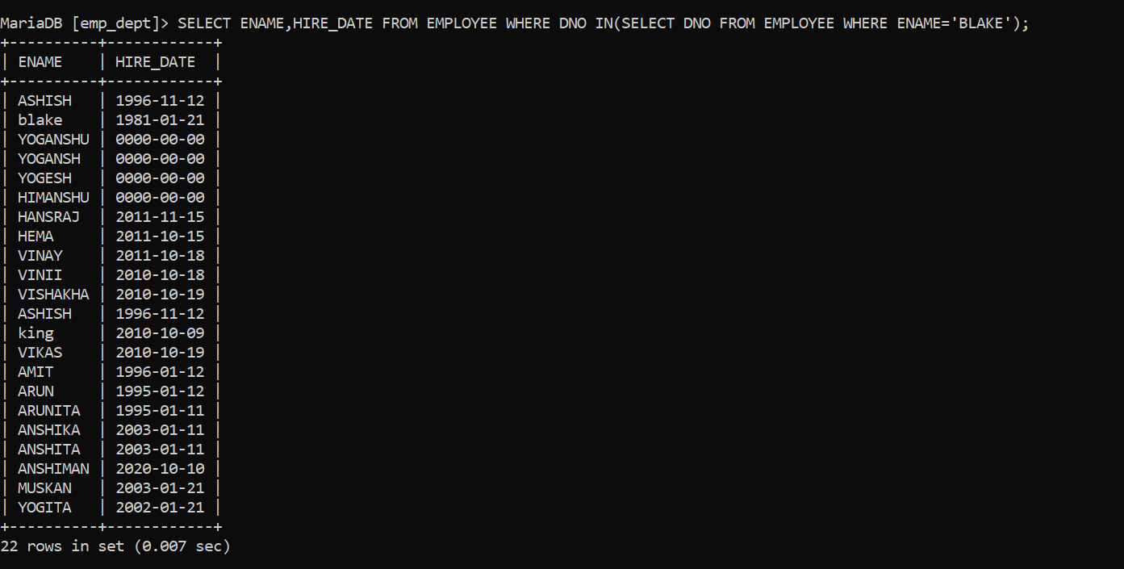

**34. Query to display the Employee No. And Name for all employees who earn more than the average salary.**

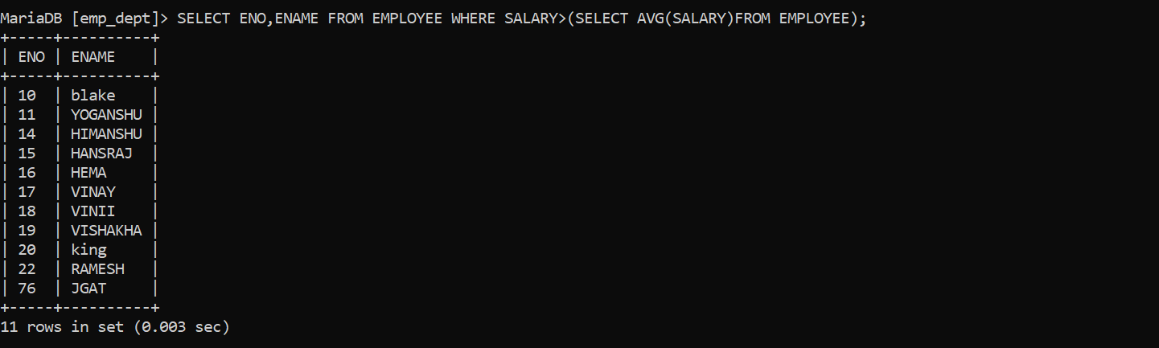

**35. Query to display Employee Number and Name for all employees who work in a department with any employee whose name contains a ‘T’.**

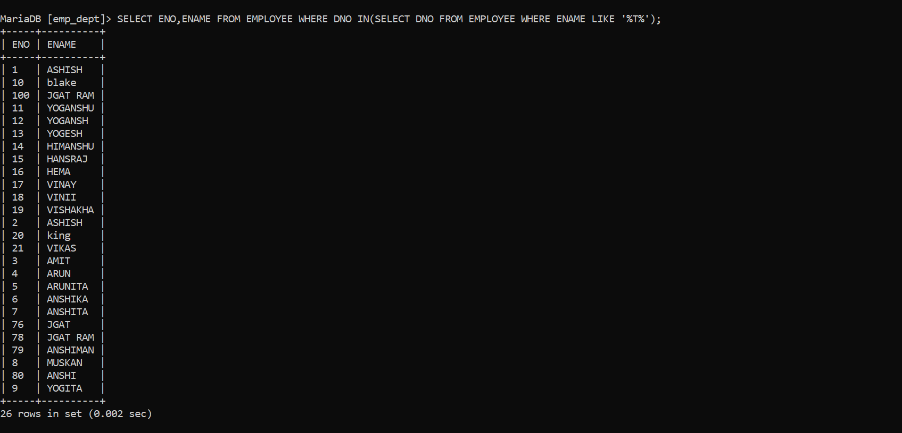

**36. Query to display the names and salaries of all employees who report to supervisor named ‘King’**

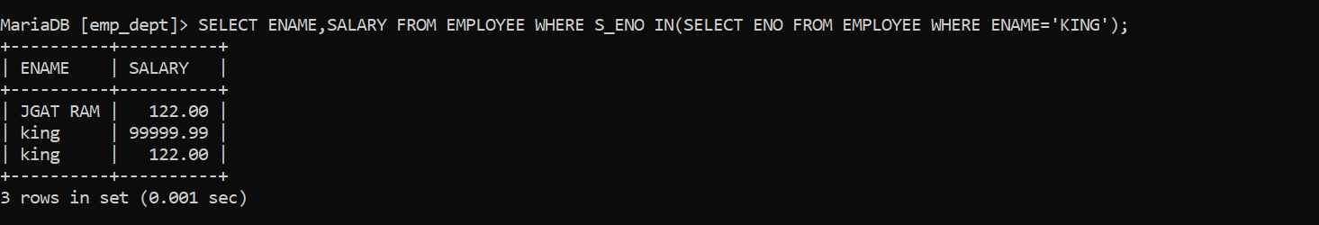

**37. Query to display the department no, name and job for all employees in the Sales department**

